TERN Data Licensing Policy

Version 4.0

Copyright © TERN (University of Queensland)
Content in this publication is licensed under Creative Commons Attribution 4.0 International Licence, available at http://creativecommons.org/licenses/by/4.0/

Release Authorisation

File Name | TERN Data Licencing Policy
Version | 4.0
Release Authority | TERN Director

Document History

Version | Date | Approved By | Change Log | Document Author
1.0 | 2012 | TERN IIDDG | Created the first version of TERN data licencing policy document | Alison Bradshaw
2.0 | April 2015 | TERN IIDDG | The second version: support for CC 4.0 international | Alison Bradshaw
3.0 | Oct 2015 | TERN IIDDG | The document is simplified with core data sharing principles, endorses the CC BY 4.0 international as default licence, de-commissioned the use of TERN suite of licences for future data publications. | Siddeswara Guru
3.1 | June 2018 | TERN TEG | Updated the document to reflect new TERN structure | Siddeswara Guru
3.2 | March 2019 |  | Fixed Few typos | Angela Gackle & Siddeswara Guru
3.3 | November 2021 |  | Updated terms to ensure consistent naming of platforms, data and data products. Document has been formatted following the new TERN branding template. | Anusuriya Devaraju, Mark Grant and Kathy Mason
4.0 | October 2022 |  | Document has been updated with the TERN template for consistency, fixed few typos | Siddeswara Guru

Introduction
The Terrestrial Ecosystem Research Network (TERN) is an initiative funded under the Australian Government’s National Collaborative Research Infrastructure Strategy (NCRIS). As a publicly funded national research infrastructure, any datasets collected and collated by TERN will be made publicly accessible through TERN data eInfrastructure for maximum reuse.

Purpose
This document is an over-arching TERN-wide policy on data licensing. As a public document, this Policy is the primary, authoritative reference point (for TERN, stakeholders, partners and collaborators) about TERN’s data access and publication policy. The current version of the document is a refinement on the previous versions of data licensing policy. The updated data licensing policy applies to all new datasets and data products created or acquired by TERN for publication. All the datasets previously published in agreement with the previous policy are valid and will not breach any TERN data licensing policy.

The data licensing policy has been developed to implement the principle of open access to terrestrial ecosystem data published by TERN Data Services and Analytics. The objective of the policy is to ensure that:
- All data generated, provided (data provided by external parties) and published through TERN will be made freely and openly accessible, noting that:
  - Users will be required to attribute the source of the data; and
  - Justifiable conditions protecting sensitivities of data will be allowed.
- The rights and obligations of the use of data will be made explicit to the users at the time of access.

Scope
The data licensing policy will apply to all datasets and products created by TERN and acquired from external data sources by TERN. To drive data-driven innovation, TERN has a clear principle promoting open access to data. TERN has a default position to provide open access to data with the exception only if required for privacy, security, sensitivity, embargo or confidentiality reasons.

Responsibilities
The data licensing policy applies to all TERN platforms, employees and data users. All TERN platforms must implement the policy requirements to all newly created and acquired datasets, which are published under new data provider deeds. Any data provider deeds made prior to the existence of this policy are still valid. Everybody must ensure that the policy is applied to the licensing of all the datasets published both for internal and external use.

Policy Principles
TERN is committed to publishing all publicly funded terrestrial ecosystem research data to a broader user community for easy access and where possible, re-use. All data published by TERN will be appropriately described, discoverable and accessible with least restrictions. After wider consultation with internal and external TERN stakeholders, TERN has determined that the following data licensing policy principles will be applied to TERN and its capabilities:

Principle 1: Identify ownership of Intellectual Property
Before licensing any data, TERN should identify who owns the Intellectual Property Rights (IPR) associated with the data. Any IPR associated with TERN-generated data or products lie with the generating agency. However, TERN will have non-exclusive, irrevocable, sub-licensable, perpetual royalty-free worldwide license to use the IP materials. If data is acquired from external parties or organisations, they may own some or all IPR on the data. Any pre-existing IPR [in data] will be recognised and respected and will only be used as authorised by the owner of the IPR or as permitted under Law.

Principle 2: Identify any restrictions on distribution
TERN should identify any restrictions on the use of data due to privacy, security, sensitivity or confidentiality reasons. Publication of sensitive data should meet the commonwealth and state government legislative requirements.

Principle 3: Apply least restrictive licence
TERN endorses the creative commons suite of licenses. TERN has adopted the Creative Commons 4.0 International suite of licences. TERN should apply the most open licence possible, which requires attribution while observing any restrictions identified in Principle 2. The Creative Commons – Attribution 4.0 International (CC BY 4.0) is the default data licence supported by TERN because it is the most open of all Creative Commons licences, which requires attribution. The Creative Commons By Attribution lets others distribute, remix, tweak, and build upon others’ work, even commercially, as long as they credit the original creator. The CC BY is the most accommodating of licences available, recommended for maximum dissemination and reuse of licensed data where creators get credit for their contribution.
Other Creative Commons licences or similar licences can be applied to the datasets in exceptional cases such as:
- Pre-existing licence conditions on the data;
- Privacy, security, sensitivity, and confidentiality concerns.

Principle 4: Rights and obligations for use of data are clearly presented
To maximise appropriate re-use of data made available through TERN data infrastructure, the rights and obligations attaching to the data will be made clear to the data users, preferably in the metadata about that data. The licence information will also be displayed explicitly including:
- The URL of the Creative Commons licence used;
- The creators name;
- The year of creation;
- Attribution statement to cite the dataset.
TERN will manage datasets in accordance with its licence and comply with all the licencing conditions.

Principle 5: No Warranty on data
TERN, its platforms, and the data providers will not be required to make any warranty regarding the quality, accuracy, completeness, currency, relevance or suitability for any purposes. Data will be made available on the understanding that data users will, at their risk, exercise their skill, judgement and care on their use of or reliance on the data.

Principle 6: Make data widely discoverable
TERN may feed metadata to national and international repositories to improve discoverability thus, increasing the possible re-use of data. Figure 1 shows a schematic representation of the application of the TERN Data Licensing Policy.
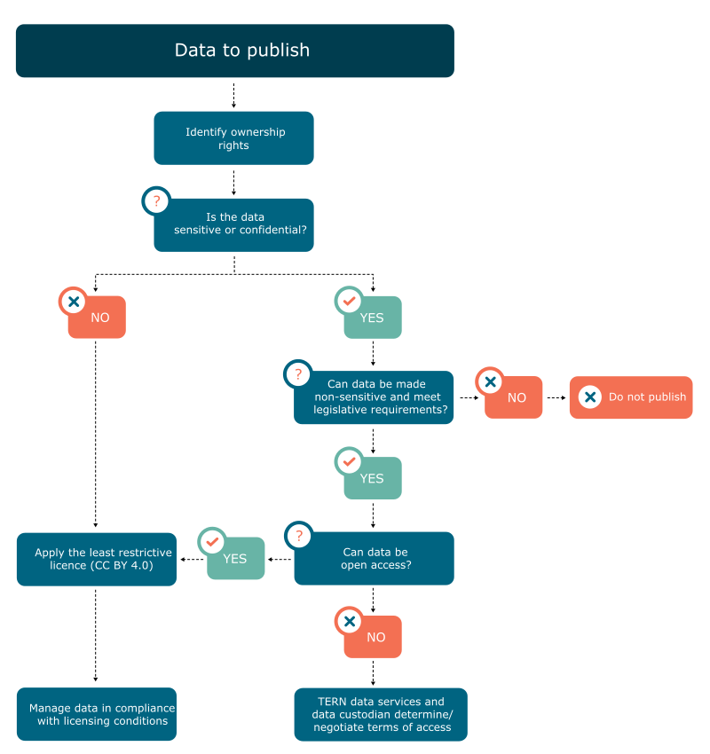

Figure 1: Application of TERN Data Licensing Policy

Definitions
Data | Information or facts made available in a consumable form.
Metadata | A set of contextual information that describes data.
Intellectual Property Rights (IPR) | Rights granted to creators over the creation of data. The creator of IP may not be the owner.
External parties | People or organisations not directly funded by TERN but who use TERN infrastructure to publish data.
Data user | Users of data published by TERN.
Data provider | A person or organisation that has a statutory and operational authority over the data.
Sensitive data | Data that if published or shared may increase the risk of destruction and/or adverse effect on a species or ecosystem.
Data publication | The outcome of data management including data curation, description of data in suitable metadata standards and making the data accessible with least restriction.
Data licence | Permission granted by data creator or owner to use the data under terms of use.

Contact Details
TERN, in consultation with the wider stakeholders, manages the data licensing policy. Please contact the TERN Data Services and Analytics Platform Lead or the TERN Director to provide any feedback or comments.

Document Control
Policy Location | http://www.tern.org.au/datalicence  Hardcopies of this document are considered uncontrolled. Please refer to the TERN website for the latest version.
Policy Custodian | TERN Director
Approved by | TERN Executive Group
Contact for queries | TERN Data Services and Analytics Platform Lead: tern.data@uq.edu.au  TERN Director: tern.director@uq.edu.au

We at TERN acknowledge the Traditional Owners and Custodians throughout Australia, New Zealand
and all nations. We honour their profound connections to land, water, biodiversity and culture and
pay our respects to their Elders past, present and emerging.

TERN is enabled by NCRIS. Our work is a result of collaborative partnerships with many universities and institutions.
To find out more please go to tern.org.au.

